*Tectonics*

Supporting Information for

**Slip Distribution along the Chenghai fault from airborne LiDAR and tectonic implications for the 1515 Yongsheng earthquake, China**

Haomin Ji1, 2, Zhikun Ren1, 2*, Xiaoxiao Zhu1, 2, Mingkun Bai1, 2, Guodong Bao1,2, Jinrui Liu1, 2, Guanghao Ha1, 2, Zhongtai He1, 2

1State Key Laboratory of Earthquake Dynamics, Institute of Geology, China Earthquake Administration, Beijing, 100029, China

2Key Laboratory of Seismic and Volcanic Hazards, China Earthquake Administration, Beijing, 100029, China

**Contents of this file**

Figures S1 to S5

Table S2 to S3

**Additional Supporting Information (Files uploaded separately)**

Captions for Tables S1 and Table S4

Captions for Data Set A1

References From the Supporting Information

**Introduction**

Figure S1 shows the process of the displacement measurement method. Figure S2 presents all topographic profiles. Figure S3 and S4 give the raw images to facilitate readers to identify the fault trace. Figure S5 gives the calculation results of the cumulative offset probability density based on the horizontal displacements along the S2 and S3 segments. Table S1 displays all horizontal displacement measurements along the Chenghai Fault. Table S2 shows the magnitude estimate of the Yongsheng earthquake in 1515 based on empirical formulas. Table S3 presents the slip rate of active faults in the Sichuan-Yunnan block revealed by the geodesy. Table S4 presents late Quaternary horizontal slip rate of active faults in the Sichuan-Yunnan block. Data Set S1 includes a kmz file of the mapped fault trace. Finally, all references in the Supporting Information are listed.

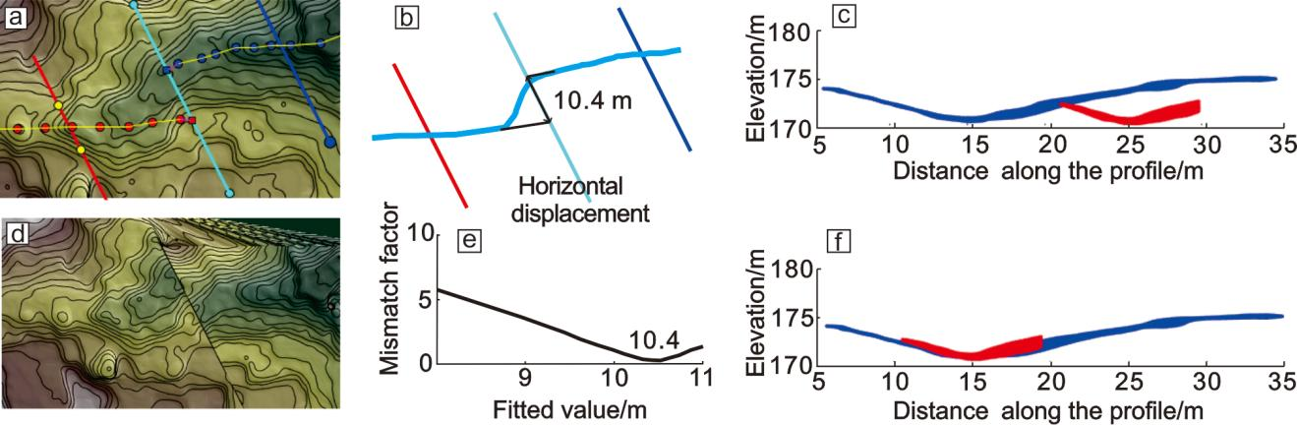

Figure S1. Displacement measurement method based on high resolution DEM data

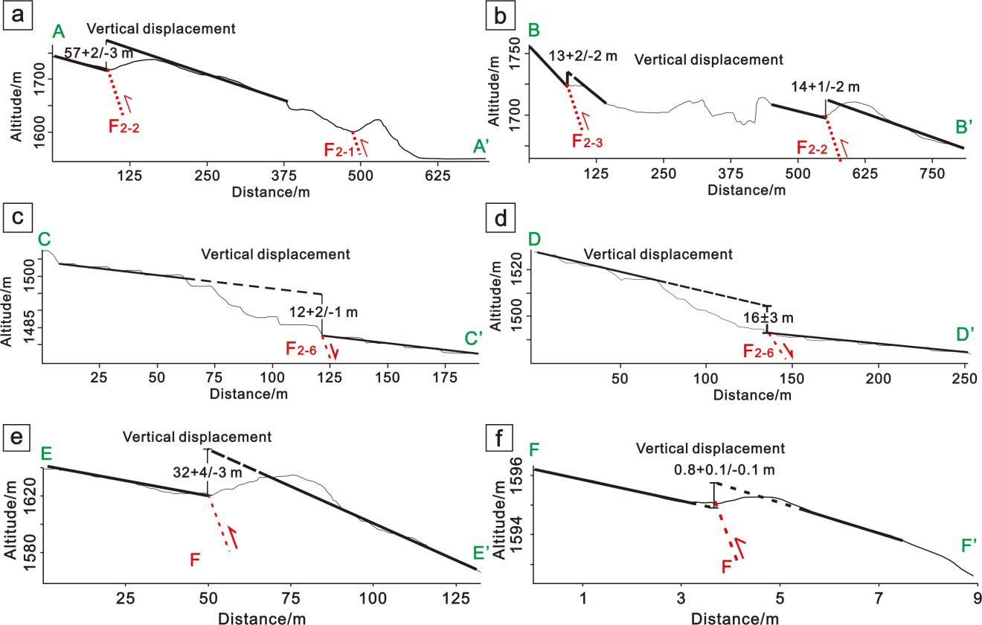

**Figure S2**. Topographic profiles. The locations of AA’ and BB’ are shown in Fig. 5a; the locations of CC’ and DD’ are shown in Fig. 6a; the locations of EE’ and FF’ are shown in Fig. 7d

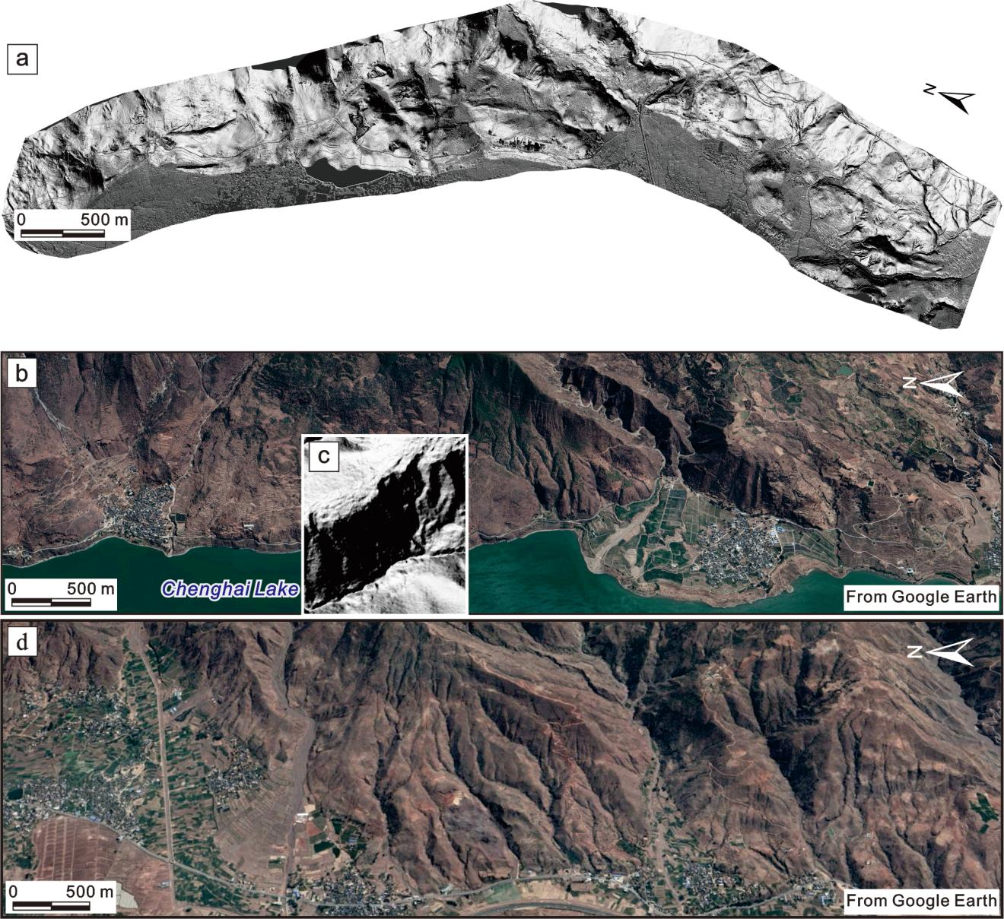

Figure S3. Raw images for interpretation figures in the body content. a: Fig. 5a; b, c: Fig. 5d, e; d: Fig. 6f

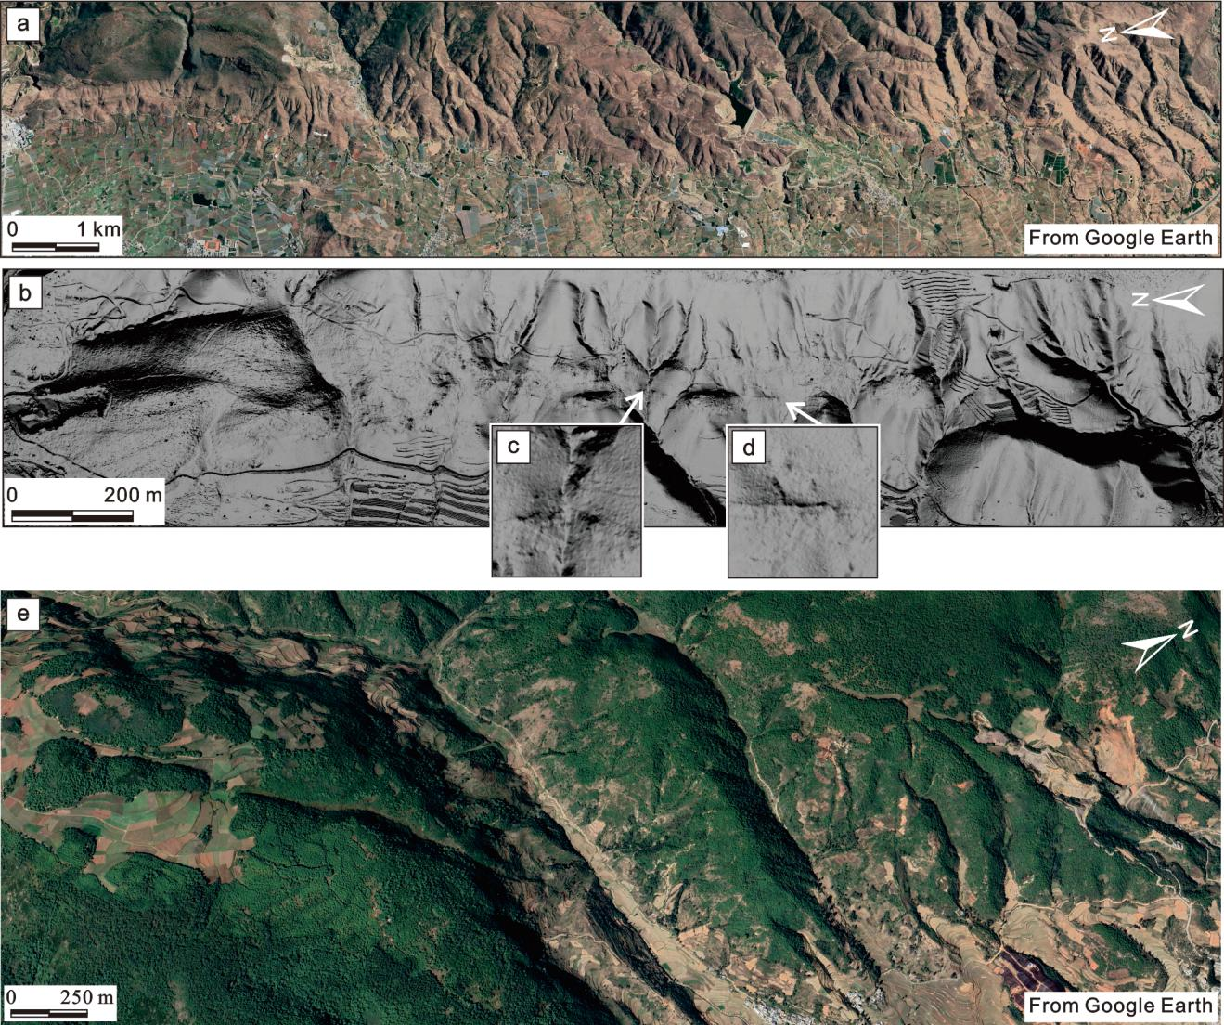

**Figure S4**. Raw images for interpretation figures in the body content. a: Fig. 7c; b, c, d: Fig. 7d, e, f; e: Fig. 8c

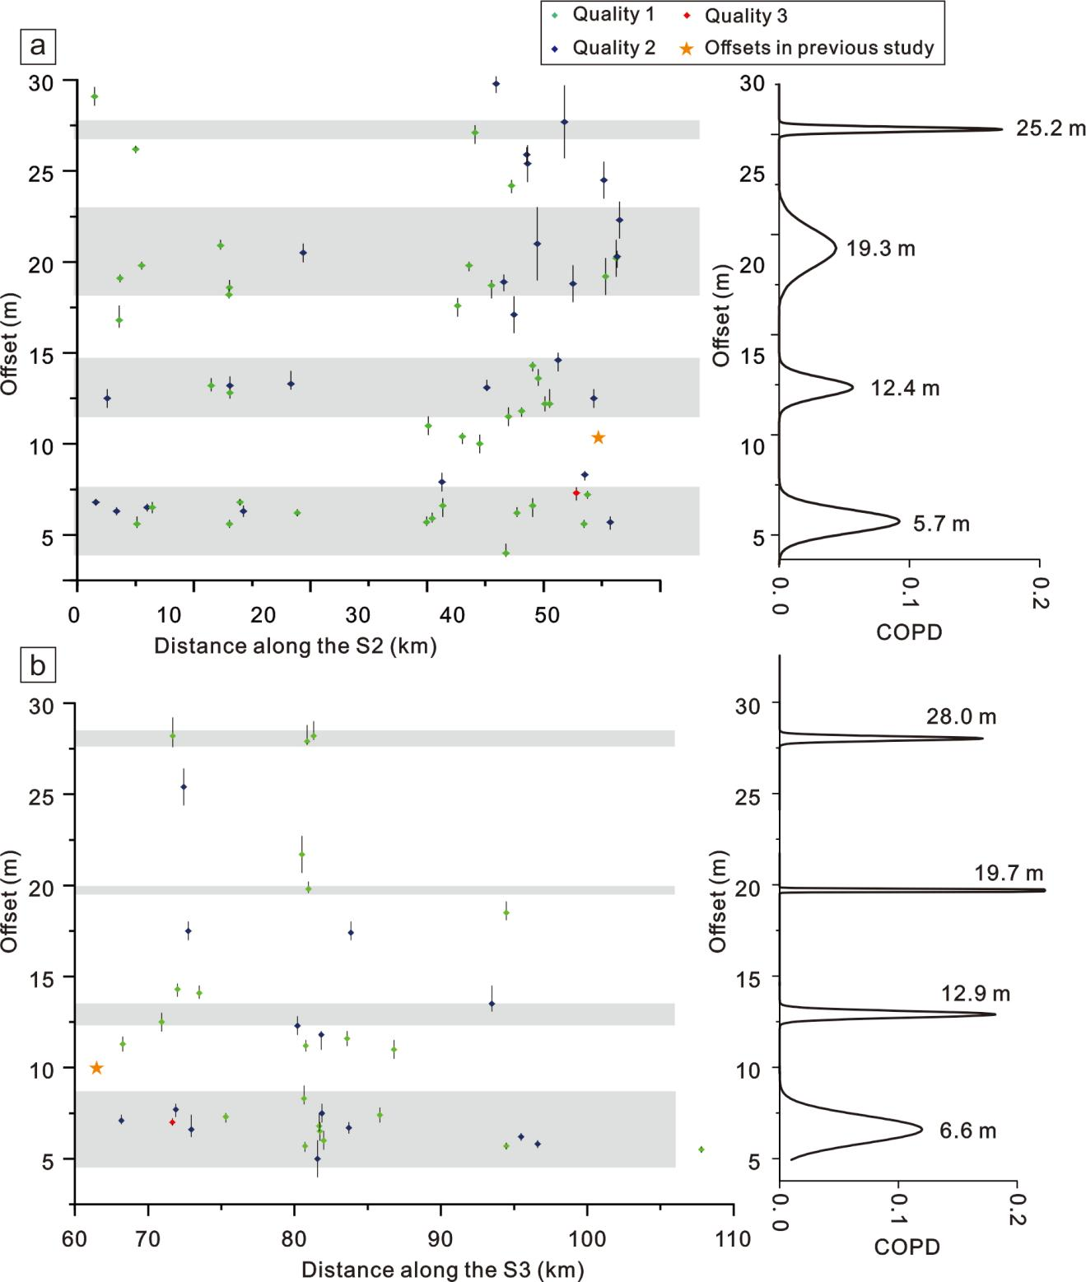

Figure S5. Cumulative offset probability density (COPD) plot of the horizontal displacements on segment 2 (a) and 3 (b) of the Chenghai Fault in the range of 0–30 m

**Table S1.** Distribution of the coseismic displacement along the Chenghai fault

**Table S2.**  Magnitude estimate of the Yongsheng earthquake in 1515

|  |  |  |  |  |
| --- | --- | --- | --- | --- |
| **Equation** | **a** | **b** | **Calculated SRL** | **Reference** |
| SRL = a + blogDco | 1.46 | 0.86 | 138 km | Wells and Coppersmith, 1994 |
| **Equation** | **c** | **d** | **Calculated magnitude** | **Reference** |
| M = c + dlogSRL | 5.92 | 0.88 | 7.77 | Deng et al., 1992 |
| 5.16 | 1.12 | 7.51 | Wells and Coppersmith, 1994 |
| 5.303 | 1.181 | 7.78 | Ran, 2011 |
| **Equation** | **e** | **f** | **Calculated magnitude** | **Reference** |
| M = e + flogAD | 7.13 | 0.68 | 7.74 | Deng et al., 1992 |
| 6.83 | 0.97 | 7.59 | Wells and Coppersmith, 1994 |
| 6.996 | 0.854 | 7.67 | Ran, 2011 |

**Table S3.** The slip rate of active faults in the Chuandian block revealed by the geodesy

|  |  |  |  |  |  |  |  |
| --- | --- | --- | --- | --- | --- | --- | --- |
| **Active fault** | **Horizontal Slip Rate（mm/a）** | **Method** | **Reference** | **Active fault** | **Horizontal Slip Rate（mm/a）** | **Method** | **Reference** |
| Xianshuihe fault | 10-11 | GPS | Shen et al., 2005 | Xiaojiang fault | ~7 | GPS | Shen et al., 2005 |
| 8.9-17.1 | GPS | Wang et al.，2008 | 9.4 ± 1.2 | GPS | Wang et al.，2008 |
| 11.8 -14.5 | GPS | Wang et al., 2020 | 13.2 ± 0.2 | GPS | Wang et al., 2020 |
| 9-12 | InSAR | Wang et al.，2009 | Lijiang-Xiaojinhe fault | ~3 | GPS | Shen et al., 2005 |
| 12.2-13 | GPS | Wang W. et al., 2017 | 5.4 ± 1.2 | GPS | Wang et al.，2008 |
| 12.7-15.9 | GPS | Wang Y. et al. 2017 | 4.3 | GPS | Wang et al., 2020 |
| 9-12 | InSAR | Ji et al., 2020 | Litang  fault | 4.4 ± 1.3 | GPS | Wang et al.，2008 |
| 8-10.2 | GPS | Zheng et al., 2017 | 3.1 ± 0.8 | GPS | Wang et al., 2020 |
| 10-15 | InSAR | Zhang et al., 2019 | Nanhua-Chuxiong fault | 4.2 ± 1.3 | GPS | Wang et al.，2008 |
| 8.1-11.1 | InSAR | Qiao and Zhou, 2021 | 2.1 ± 0.8 | GPS | Li et al., 2020 |
| 7.67-9.13 | Gravity and GPS | Li et al., 2019 | Shiping-Jianshui fault | 1.7 ± 0.7-2.2 ± 0.8 | GPS | Li et al., 2020 |
| 14.4 | GPS | Gan et al., 2007 | 4.2 ± 1.3 | GPS | Wang et al.，2008 |
| 7-10.3 | GPS and InSAR | Jiang, et al. 2015 | Qujiang fault | 2.8 ± 1.4 | GPS | Li et al., 2020 |
| 11 | GPS | Loveless and Meade | Red River  fault | 0.8 | GPS | Wang W. et al., 2017 |
| Anninghe-Zemuhe fault | 4.4-6.2 | GPS | Wang W. et al., 2017 | <2 | GPS | Shen et al., 2005 |
| ~7 | GPS | Shen et al., 2005 | 0.4-1.5 | GPS | Wang et al.，2008 |
| 5.1 ± 2.5 | GPS | Wang et al.，2008 | 1.3 ± 0.4-4.2 ± 1.0 | GPS | Wang et al., 2020 |
| 4.7 ± 0.7-5.3 ± 0.4 | GPS | Wang et al., 2020 | 1.4 ± 0.4 | GPS | Li et al., 2020 |
| Daliangshan fault | 6 | GPS | Wang W. et al., 2017 | Lancangjiang fault | ~2 | GPS | Shen et al., 2005 |
| 6.3 ± 0.5 | GPS | Wang et al., 2020 | Jinshajiang fault | 1.9 ± 0.8 | GPS | Wang et al., 2020 |

**Table S4.**  The slip rate of active faults in the Chuandian block revealed by the geological research

Data Set S1. A kmz file of the mapped fault trace based on the LiDAR-DEM.

**References From the Supporting Information**

Bai, M., Chevalier, M., Pan, J., Replumaz, A., Leloup, P. H., Métois, M., et al. (2018). Southeastward increase of the late Quaternary slip-rate of the Xianshuihe fault, eastern Tibet. Geodynamic and seismic hazard implications. *Earth and Planetary Science Letters*, 485, 19–31. https://doi.org/10.1016/j.epsl.2017.12.045

Bai, M., Chevalier, M., Leloup, P., Li H., Pan J., Replumaz, A., et al. (2021). Spatial slip rate distribution along the SE Xianshuihe fault, eastern Tibet, and earthquake hazard assessment. *Tectonics*, 40, e2021TC006985. https://doi.org/10.1029/2021TC006985

Chang, Z. F., Chang, H., Li, J. L., Hou, J. X., Song, Z. F., & Mao, D. P. (2015). Late Quaternary activity of the Chuxiong-Nanhua fault and the 1680 Chuxiong M63/4 earthquake. *Earthquake Research in China*, 31(03), 492-500 (in Chinese with English Abstract).

Chen, G., Xu, X., Wen, X., & Chen, Y. G. (2016). Late Quaternary slip-rates and slip-partitioning on the southeastern Xianshuihe fault system, Eastern Tibetan Plateau. *Acta Geologica Sinica (English edition)*, 90, 537–554. https://doi.org/10.1111/1755-6724.12689.

Deng, Q. D., Yu, G. H., & Ye, W. H. (1992). “Study on the Relations between Parameters of Surface Rupture and Magnitude,”. Research on Active Fault (2) in Institute of Geology (Beijing: Seismological Press), 247-264. (in Chinese with English abstract).

Gan, W., Zhang, P., Shen, Z., Niu, Z., Wang, M., Wan, Y., et al. (2007). Present-day crustal motion within the Tibetan Plateau inferred from GPS measurements. *Journal of Geophysical Research*, 112, B08416. https://doi.org/10.1029/2005JB004120

Gao, Y., Ding, R., Zhang, S., & Ren, J. (2019). Slip Rate of Lijiang-Xiaojinhe Fault in the Holocene. *Technology for Earthquake Disaster Prevention*, (03), 617-627 (in Chinese with English abstract).

He, H., & Oguchi, T. (2008). Late Quaternary activity of the Zemuhe and Xiaojiang Faults in southwest China from geomorphological mapping. *Geomorphology*, 96(1-2), 62–85. https://doi.org/10.1016/j.geomorph.2007.07.009.

Hu, M., Wu, Z., Li, J., Zhang, K., Reicherter, K. R., & Bi, W. (2021). Late Quaternary left-lateral strike slip rate along the Anninghe-Zemuhe Section of the Xianshuihe-Xiaojiang Fault System and its implication to the clockwise block rotation of the SE margin of the Tibetan Plateau. *Geochemistry, Geophysics, Geosystems*, https://doi.org/10.1002/essoar.10505860.2.

Institute of Geology, State Seismological Administration and Yunnan Seismological Administration (IGSYSA). 1990. Active fault in northwest Yunnan province. Seismological Press. (in Chinese)

Jiang, G., Xu, X., Chen, G., Liu, Y., Fukahata, Y., Wang, H., et al. (2015). Geodetic imaging of potential seismogenic asperities on the Xianshuihe-Anninghe-Zemuhe fault system, southwest China, with a new 3-D viscoelastic interseismic coupling model. *Journal of Geophysical Research: Solid Earth*, 120, 1855–1873. https://doi.org/10.1002/2014JB011492

Ji, L., Zhang, W., Liu, C., Zhu, L., Xu, J., & Xu, X. (2020). Characterizing interseismic deformation of the Xianshuihe fault, eastern Tibetan Plateau, using Sentinel-1 SAR images. *Advances in Space Research*, 66, 378–394. https://doi.org/10.1016/j.asr.2020.03.043

Loveless, J. P., & Meade, B. J. (2011). Partitioning of localized and diffuse deformation in the Tibetan Plateau from joint inversions of geologic and geodetic observations. *Earth and Planetary Science Letters*, 303(1–2), 11–24. https://doi.org/10.1016/j.epsl.2010.12.014

Li, T., Zhu, Y., Yang, Y., Xu, Y., An, Y., Zhang, Y., et al. (2019). The current slip rate of the Xianshuihe fault zone calculated using multiple observation data of crustal deformation. *Chinese Journal of Geophysics*, 62(4), 1323–1335 (in Chinese with English abstract)

Li, C., Wang, Y., Gan, W., Fang, L., Zhou, R., Seagren, E. G., et al. (2020). Diffuse deformation in the SE Tibetan Plateau: New insights from geodetic observations. *Journal of Geophysical Research: Solid Earth*, 125, e2020JB019383. https://doi.org/10.1029/2020JB019383

Qiao, X., & Zhou, Y. (2021). Geodetic imaging of shallow creep along the Xianshuihe fault and its frictional properties. *Earth and Planetary Science Letters*, 567, 117001. https://doi.org/10.1016/j.epsl.2021.117001

Ren, J. (1994). Late Quaternary displacement and slip rate of Zemuhe Fault in Sichuan, China. *Seismology and Geology*, 16(2), 146 (in Chinese with English abstract).

Ran, H. L. (2011). Empirical Relations between Earthquake Magnitude and Parameters of Strike-Slip Seismogenic Active Faults Associated with Historical Earthquakes in Western China. *Seismology Geology*. 33 (3), 577–585. (in Chinesewith English abstract).

Shen, Z., Lu, J., Wang, M., & Bürgmann, R. (2005). Contemporary crustal deformation around the southeast borderland of the Tibetan Plateau. *Journal of Geophysical Research*, 110, B11409. https://doi.org/10.1029/2004JB003421.

Shi, X., Sieh, K., Weldon, R., Zhu, C., Han, Y., Yang, J., et al. (2018a). Slip rate and rare large prehistoric earthquakes of the Red River fault, Southwestern China. *Geochemstry, Geophysics, Geosystems*, 19, 2014–2031. https://doi.org/10.1029/2017GC007420

Wang, Y., Wang, E., Shen, Z., Wang, M., Gan, W., Qiao, X., et al. (2008). Inversion of current activity rates of major faults in Sichuan-Yunnan region based on GPS data constraints. *Science China Earth Sciences*, 38(5), 582–597 (in Chinese with English abstract).

Wang, Y., Zhang, B., Hou, J., & Ai, X. (2015). Late Quaternary Activity of the Qujiang Fault and Analysis of the Slip Rate. *Seismology and Geology*, 37(4), 1177-1192 (in Chinese with English abstract).

Wei, Z., He, H., Shi, F.,Xu, Y., Bi, S., & Sun, H. (2012). Slip rate on the south segment of Daliangshan Fault zone. *Seismology and Geology*, 34(2): 282—293 (in Chinese with English abstract).

Wang, H., Wright, T. J., & Biggs, J. (2009). Interseismic slip rate of the northwestern Xianshuihe fault from InSAR data. *Geophysical Research Letters*, 36, L03302. https://doi.org/10.1029/2008GL036560

Wang, Y., Zhang, B., Hou, J., & Ai, X. (2015). Late Quaternary Activity of the Qujiang Fault and Analysis of the Slip Rate. *Seismology and Geology*, 37(4), 1177-1192 (in Chinese with English abstract).

Wang, Y., Wang, M., & Shen, Z. (2017). Block-like versus distributed crustal deformation around the northeastern Tibetan plateau. *Journal of Asian Earth Sciences*, 140, 31–47. https://doi.org/10.1016/j.jseaes.2017.02.040

Wang, H., Ran, Y., Chen, L., Liang, M., Gao, S., Li, Y., & Xu, L. (2018). Determination of Slip Rate on the Southern Segment of the Anninghe Fault. *Seismology and Geology*, 40 (5): 967-979 (in Chinese with English abstract).

Wang, W., Qiao, X., Yang, S., & Wang, D. (2017). Present-day velocity field and block kinematics of Tibetan Plateau from GPS measurements. *Geophysical Journal International*, 208, 1088–1102. https://doi.org/10.1093/gji/ggw445

Wang, W., Qiao, X., & Ding, K.. (2020). Present-Day Kinematics in Southeastern Tibet Inferred From GPS Measurements. *Journal of Geophysical Research: Solid Earth*, 126, e2020JB021305. https://doi.org/10.1029/2020JB021305

Xu, X., Wen, X., Zheng, R., Ma, W., Song, F., & Yu, G. (2003). Newly Tectonic Deformation and its Dynamic Source of the Sichuan-Yunnan Block. *Science in China (Ser D)*, 33(4), 151–162 (in Chinese with English abstract).

Zhang, Y., Yao, X., Yu, K., Du G., & Guo, C. (2016). Late Quaternary slip-rate and seismic activity of the Xianshuihe fault zone in southwest China. *Acta Geologica Sinica (English Edition)*. 90, 525–536. https://doi.org/10.1111/1755-6724.12688

Zheng, G., Wang, H., Wright, T. J., Lou, Y., Zhang, R., Zhang, W., et al. (2017). Crustal deformation in the India-Eurasia collision Zong from 25 years of GPS measurements. *Journal of Geophysical Research: Solid Earth*, 122, 9290–9312. https://doi.org/10.1002/2017JB014465

Zhang, L., Cao, D., Zhang, J., & Sui, L. (2019). Interseismic fault movement of Xianshuihe fault zone based on across-fault deformation data and InSAR. *Pure and Applied Geophysics*, 176, 649–667. https://doi.org/10.1007/s00024-018-1989-4